Traditional Grammar

🔹 What is Traditional Grammar
# Source: Chatgpt (GPT-4-turbo) at [8/3/2025]
Traditional grammar is the system of grammatical rules and terminology that has been passed down through centuries, largely based on the grammar of Latin and Greek.
It focuses on categorizing parts of speech, sentence structure, and prescribing proper usage—often in a formal and academic context.

✅ Key Features of Traditional Grammar:
# Source: Chatgpt (GPT-4-turbo) at [8/3/2025]
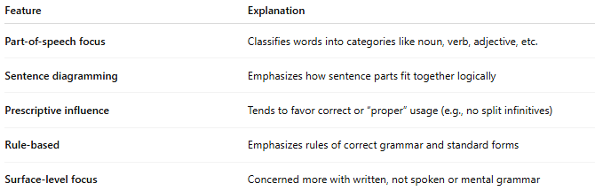
Feature | Explanation
Part-of-speech focus | Classifies words into categories like noun, verb, adjective, etc.
Sentence diagramming | Emphasizes how sentence parts fit together logically
Prescriptive influence | Tends to favor correct or “proper” usage (e.g., no split infinitives)
Rule-based | Emphasizes rules of correct grammar and standard forms
Surface-level focus | Concerned more with written, not spoken or mental grammar

✅ Components of Traditional Grammar:
# Source: Chatgpt (GPT-4-turbo) at [8/3/2025]
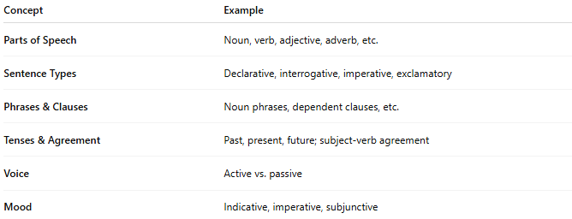
Concept | Example
Parts of Speech | Noun, verb, adjective, adverb, etc.
Sentence Types | Declarative, interrogative, imperative, exclamatory
Phrases & Clauses | Noun phrases, dependent clauses, etc.
Tenses & Agreement | Past, present, future; subject-verb agreement
Voice | Active vs. passive
Mood | Indicative, imperative, subjunctive

✅ Examples of Traditional Grammar Rules:
# Source: Chatgpt (GPT-4-turbo) at [8/3/2025]
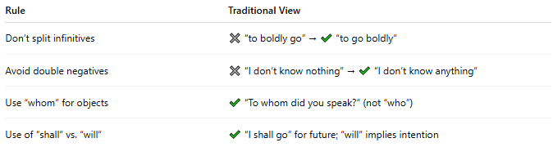
Rule | Traditional View
Don’t split infinitives | ✖ “to boldly go” → ✔ “to go boldly”
Avoid double negatives | ✖ “I don’t know nothing” → ✔ “I don’t know anything”
Use “whom” for objects | ✔ “To whom did you speak?” (not “who”)
Use of “shall” vs. “will” | ✔ “I shall go” for future; “will” implies intention

✅ Traditional Grammar vs. Other Types:
# Source: Chatgpt (GPT-4-turbo) at [8/3/2025]
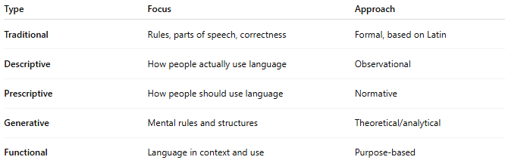
Type | Focus | Approach
Traditional | Rules, parts of speech, correctness | Formal, based on Latin
Descriptive | How people actually use language | Observational
Prescriptive | How people should use language | Normative
Generative | Mental rules and structures | Theoretical/analytical
Functional | Language in context and use | Purpose-based

✅ Why Traditional Grammar Matters:
# Source: Chatgpt (GPT-4-turbo) at [8/3/2025]
- Serves as the foundation of grammar instruction in schools
- Introduces clear, familiar terminology (noun, verb, etc.)
- Useful for learning foreign languages, especially Latin-based ones
- Supports clear writing and sentence construction

📝 Summary:
# Source: Chatgpt (GPT-4-turbo) at [8/3/2025]
- Traditional grammar is the classical framework of grammar rules and categories.
- Emphasizes parts of speech, sentence structure, and proper usage.
- Influenced by Latin and Greek models.
- Still widely used in education, grammar books, and standardized tests.

